Department of Information Engineering Technology The Superior University, Lahore

Mobile Application Development Lab

Experiment No.11
Flutter: API integration

Prepared for

Ms Isha Nawaz

By:
Name
Awais Ali Raza: SU91-BIETM-F23-053
Azeem Liaqat: SU91-BIETM-F23-072
Jahanzaib Ali: SU91-BIETM-F23-056
Toseef Ahmad: SU91-BIETM-F23-043
Nigar Fatima: SU91-BIETM-F23-045

Total Marks:

Obtained Marks:

Signature:

Date:

Experiment No.11
Flutter: API integration
(Rubrics)
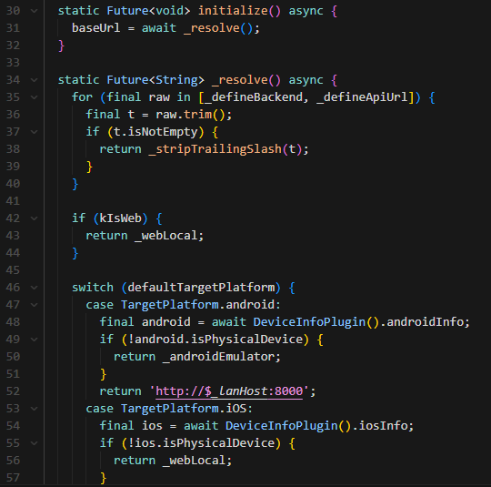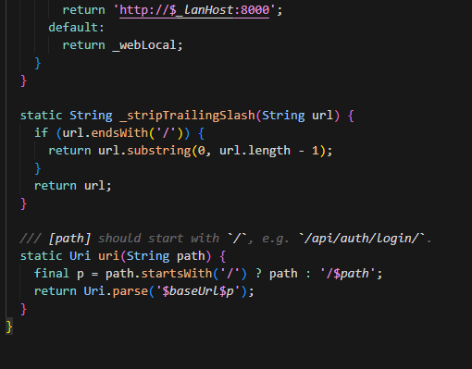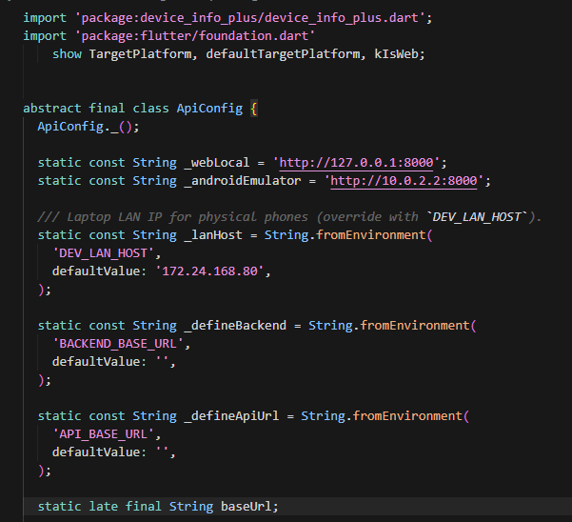
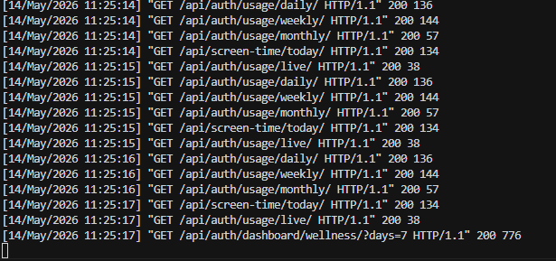

Subscription Plans
import 'subscription_service.dart';

class PlanAccessService {
PlanAccessService._();
static final PlanAccessService instance = PlanAccessService._();

CurrentSubscriptionModel? _cached;
DateTime? _lastFetchedAt;
static const Duration _cacheTtl = Duration(seconds: 20);

bool get _isCacheFresh {
if (_cached == null || _lastFetchedAt == null) return false;
return DateTime.now().difference(_lastFetchedAt!) <= _cacheTtl;
}

Future<String> currentPlanCode() async {
if (!_isCacheFresh) {
_cached = await SubscriptionService.instance.getCurrentSubscription();
_lastFetchedAt = DateTime.now();
}
return (_cached?.effectivePlanCode ?? 'free').toLowerCase();
}

Future<void> refresh() async {
_cached = await SubscriptionService.instance.getCurrentSubscription();
_lastFetchedAt = DateTime.now();
}

void invalidate() {
_cached = null;
_lastFetchedAt = null;
}

Future<bool> canAccess(String featureKey, {bool forceRefresh = false}) async {
if (forceRefresh) {
await refresh();
}
final code = await currentPlanCode();
final allowed = _featuresByPlan[code] ?? _featuresByPlan['free']!;
return allowed.contains(featureKey);
}

static const Map<String, Set<String>> _featuresByPlan = {
'free': {
'basic_mood_tracking',
'screen_time',
},
'basic': {
'emotion_detection_limited',
'basic_mood_tracking',
'screen_time',
'content_monitoring',
'analytics_day_week_month',
'chat_realtime_psychologist',
'ads_included',
},
'premium': {
'emotion_detection_limited',
'emotion_detection_full',
'basic_mood_tracking',
'screen_time',
'content_monitoring',
'analytics_day_week_month',
'chat_realtime_psychologist',
'ads_included',
'weekly_reports',
'no_ads',
'personalized_suggestions',
'chat_digital_psychologist',
'mental_health_monitoring',
'advanced_ai_insights',
'monthly_mental_health_reports',
'therapist_recommendation',
'priority_support',
'parental_control',
'full_app_access',
},
};
}
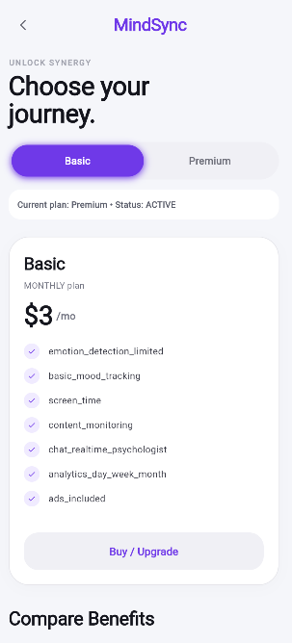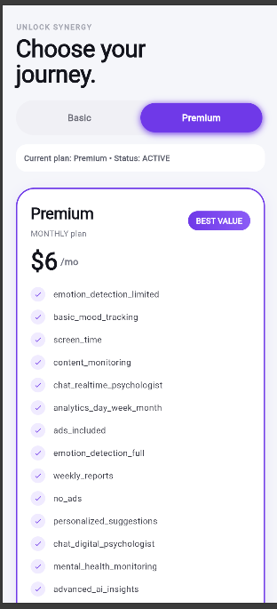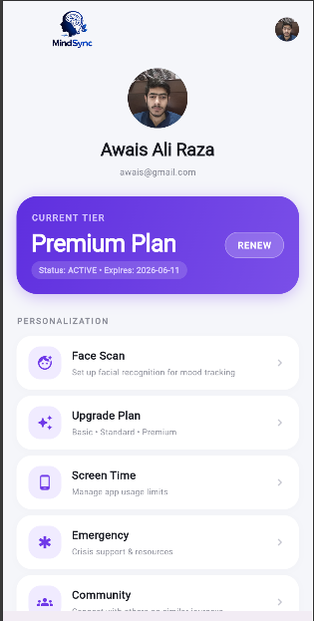

Community Service

import 'dart:convert';

import 'package:http/http.dart' as http;
import 'package:shared_preferences/shared_preferences.dart';

import '../config/api_config.dart';

class CommunityPostItem {
const CommunityPostItem({
required this.id,
required this.content,
required this.category,
required this.userName,
required this.createdAt,
required this.likesCount,
required this.commentsCount,
required this.likedByMe,
});

final int id;
final String content;
final String category;
final String userName;
final DateTime createdAt;
final int likesCount;
final int commentsCount;
final bool likedByMe;
}

class CommunityCommentItem {
const CommunityCommentItem({
required this.id,
required this.content,
required this.userName,
required this.createdAt,
});

final int id;
final String content;
final String userName;
final DateTime createdAt;
}

class DoctorItem {
const DoctorItem({
required this.id,
required this.fullName,
required this.designation,
required this.experienceYears,
required this.specialist,
required this.contactNumber,
});

final int id;
final String fullName;
final String designation;
final int experienceYears;
final String specialist;
final String contactNumber;
}

class TrustedContactItem {
const TrustedContactItem({
required this.id,
required this.name,
required this.relationship,
required this.contactNumber,
});

final int id;
final String name;
final String relationship;
final String contactNumber;
}

class DoctorChatMessageItem {
const DoctorChatMessageItem({
required this.id,
required this.sender,
required this.message,
required this.createdAt,
});

final int id;
final String sender;
final String message;
final DateTime createdAt;
}

class DoctorInboxItem {
const DoctorInboxItem({
required this.userId,
required this.userName,
required this.userEmail,
required this.lastMessage,
required this.lastSender,
required this.lastTime,
});

final int userId;
final String userName;
final String userEmail;
final String lastMessage;
final String lastSender;
final DateTime lastTime;
}

class CommunityService {
Future<Map<String, String>?> _headers() async {
final prefs = await SharedPreferences.getInstance();
final token = prefs.getString('auth.accessToken');
if (token == null || token.isEmpty) return null;
return {
'Content-Type': 'application/json',
'Authorization': 'Bearer $token',
};
}

Future<List<CommunityPostItem>> fetchPosts(String category) async {
final headers = await _headers();
if (headers == null) return const [];
final uri = Uri.parse(
'${ApiConfig.baseUrl}/api/auth/community/posts/?category=${Uri.encodeQueryComponent(category)}',
);
final res = await http.get(uri, headers: headers);
if (res.statusCode < 200 || res.statusCode >= 300) return const [];
final list = (jsonDecode(res.body) as List<dynamic>).cast<Map<String, dynamic>>();
return list
.map(
(it) => CommunityPostItem(
id: (it['id'] as num?)?.toInt() ?? 0,
content: (it['content'] ?? '').toString(),
category: (it['category'] ?? 'other').toString(),
userName: (it['user_name'] ?? 'User').toString(),
createdAt: DateTime.tryParse((it['created_at'] ?? '').toString()) ?? DateTime.now(),
likesCount: (it['likes_count'] as num?)?.toInt() ?? 0,
commentsCount: (it['comments_count'] as num?)?.toInt() ?? 0,
likedByMe: (it['liked_by_me'] as bool?) ?? false,
),
)
.toList();
}

Future<bool> createPost({
required String content,
required String category,
}) async {
final headers = await _headers();
if (headers == null) return false;
final res = await http.post(
Uri.parse('${ApiConfig.baseUrl}/api/auth/community/posts/'),
headers: headers,
body: jsonEncode({'content': content.trim(), 'category': category}),
);
return res.statusCode >= 200 && res.statusCode < 300;
}

Future<bool> toggleLike(int postId) async {
final headers = await _headers();
if (headers == null) return false;
final res = await http.post(
Uri.parse('${ApiConfig.baseUrl}/api/auth/community/posts/$postId/like/'),
headers: headers,
body: jsonEncode({}),
);
return res.statusCode >= 200 && res.statusCode < 300;
}

Future<List<CommunityCommentItem>> fetchComments(int postId) async {
final headers = await _headers();
if (headers == null) return const [];
final res = await http.get(
Uri.parse('${ApiConfig.baseUrl}/api/auth/community/posts/$postId/comments/'),
headers: headers,
);
if (res.statusCode < 200 || res.statusCode >= 300) return const [];
final list = (jsonDecode(res.body) as List<dynamic>).cast<Map<String, dynamic>>();
return list
.map(
(it) => CommunityCommentItem(
id: (it['id'] as num?)?.toInt() ?? 0,
content: (it['content'] ?? '').toString(),
userName: (it['user_name'] ?? 'User').toString(),
createdAt: DateTime.tryParse((it['created_at'] ?? '').toString()) ?? DateTime.now(),
),
)
.toList();
}

Future<bool> addComment({
required int postId,
required String content,
}) async {
final headers = await _headers();
if (headers == null) return false;
final res = await http.post(
Uri.parse('${ApiConfig.baseUrl}/api/auth/community/posts/$postId/comments/'),
headers: headers,
body: jsonEncode({'content': content.trim()}),
);
return res.statusCode >= 200 && res.statusCode < 300;
}

Future<List<DoctorItem>> fetchDoctors() async {
final headers = await _headers();
if (headers == null) return const [];
final res = await http.get(
Uri.parse('${ApiConfig.baseUrl}/api/auth/emergency/doctors/'),
headers: headers,
);
if (res.statusCode < 200 || res.statusCode >= 300) return const [];
final list = (jsonDecode(res.body) as List<dynamic>).cast<Map<String, dynamic>>();
return list
.map(
(it) => DoctorItem(
id: (it['id'] as num?)?.toInt() ?? 0,
fullName: (it['full_name'] ?? '').toString(),
designation: (it['designation'] ?? '').toString(),
experienceYears: (it['experience_years'] as num?)?.toInt() ?? 0,
specialist: (it['specialist'] ?? '').toString(),
contactNumber: (it['contact_number'] ?? '').toString(),
),
)
.toList();
}

Future<List<TrustedContactItem>> fetchTrustedContacts() async {
final headers = await _headers();
if (headers == null) return const [];
final res = await http.get(
Uri.parse('${ApiConfig.baseUrl}/api/auth/emergency/trusted-contacts/'),
headers: headers,
);
if (res.statusCode < 200 || res.statusCode >= 300) return const [];
final list = (jsonDecode(res.body) as List<dynamic>).cast<Map<String, dynamic>>();
return list
.map(
(it) => TrustedContactItem(
id: (it['id'] as num?)?.toInt() ?? 0,
name: (it['name'] ?? '').toString(),
relationship: (it['relationship'] ?? '').toString(),
contactNumber: (it['contact_number'] ?? '').toString(),
),
)
.toList();
}

Future<bool> createTrustedContact({
required String name,
required String relationship,
required String contactNumber,
}) async {
final headers = await _headers();
if (headers == null) return false;
final res = await http.post(
Uri.parse('${ApiConfig.baseUrl}/api/auth/emergency/trusted-contacts/'),
headers: headers,
body: jsonEncode({
'name': name.trim(),
'relationship': relationship.trim(),
'contact_number': contactNumber.trim(),
}),
);
return res.statusCode >= 200 && res.statusCode < 300;
}

Future<List<DoctorChatMessageItem>> fetchDoctorChat(int doctorId) async {
final headers = await _headers();
if (headers == null) return const [];
final res = await http.get(
Uri.parse('${ApiConfig.baseUrl}/api/auth/emergency/doctors/$doctorId/chat/'),
headers: headers,
);
if (res.statusCode < 200 || res.statusCode >= 300) return const [];
final list = (jsonDecode(res.body) as List<dynamic>).cast<Map<String, dynamic>>();
return list
.map(
(it) => DoctorChatMessageItem(
id: (it['id'] as num?)?.toInt() ?? 0,
sender: (it['sender'] ?? 'user').toString(),
message: (it['message'] ?? '').toString(),
createdAt: DateTime.tryParse((it['created_at'] ?? '').toString()) ?? DateTime.now(),
),
)
.toList();
}

Future<bool> sendDoctorChatMessage({
required int doctorId,
required String message,
}) async {
final headers = await _headers();
if (headers == null) return false;
final res = await http.post(
Uri.parse('${ApiConfig.baseUrl}/api/auth/emergency/doctors/$doctorId/chat/'),
headers: headers,
body: jsonEncode({'message': message.trim()}),
);
return res.statusCode >= 200 && res.statusCode < 300;
}

Future<List<DoctorInboxItem>> fetchDoctorInbox() async {
final headers = await _headers();
if (headers == null) return const [];
final res = await http.get(
Uri.parse('${ApiConfig.baseUrl}/api/auth/doctor/inbox/'),
headers: headers,
);
if (res.statusCode < 200 || res.statusCode >= 300) return const [];
final list = (jsonDecode(res.body) as List<dynamic>).cast<Map<String, dynamic>>();
return list
.map(
(it) => DoctorInboxItem(
userId: (it['user_id'] as num?)?.toInt() ?? 0,
userName: (it['user_name'] ?? 'User').toString(),
userEmail: (it['user_email'] ?? '').toString(),
lastMessage: (it['last_message'] ?? '').toString(),
lastSender: (it['last_sender'] ?? '').toString(),
lastTime: DateTime.tryParse((it['last_time'] ?? '').toString()) ?? DateTime.now(),
),
)
.toList();
}

Future<List<DoctorChatMessageItem>> fetchDoctorThreadMessages(int userId) async {
final headers = await _headers();
if (headers == null) return const [];
final res = await http.get(
Uri.parse('${ApiConfig.baseUrl}/api/auth/doctor/inbox/$userId/messages/'),
headers: headers,
);
if (res.statusCode < 200 || res.statusCode >= 300) return const [];
final list = (jsonDecode(res.body) as List<dynamic>).cast<Map<String, dynamic>>();
return list
.map(
(it) => DoctorChatMessageItem(
id: (it['id'] as num?)?.toInt() ?? 0,
sender: (it['sender'] ?? 'user').toString(),
message: (it['message'] ?? '').toString(),
createdAt: DateTime.tryParse((it['created_at'] ?? '').toString()) ?? DateTime.now(),
),
)
.toList();
}

Future<bool> sendDoctorReply({
required int userId,
required String message,
}) async {
final headers = await _headers();
if (headers == null) return false;
final res = await http.post(
Uri.parse('${ApiConfig.baseUrl}/api/auth/doctor/inbox/$userId/messages/'),
headers: headers,
body: jsonEncode({'message': message.trim()}),
);
return res.statusCode >= 200 && res.statusCode < 300;
}
}

